**Arpita Pal**

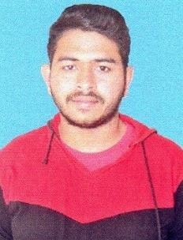

**CURRICULUM VITAE**

**Career Objective**

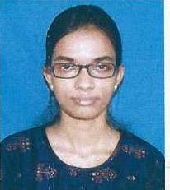Secure a responsible career opportunity to fully utilize my potentiality and skills, while making a significant contribution to the success of the company.

**Educational Qualification**

Haimantapur V.S High school, Hematpur, Paschim Medinipur

10th:73.14%**,WBBSE** , 2015

Khirpai H.S. Multipurpose school, Khirpai,Paschim Medinipur

12th:71.40%,**WBCHSE**, 2017

*  **Raja Narendra Lal Khan Women’s College**

B.Sc(Hons.) in Botany.82.50%, Passing Year-2020

* **Vidyasagar University**

M.Sc in Botany 77.17%, Passing Year-2022

Vill - Amarh, post - Hematpur, P.s -Chandrokona, Dist - Paschim Medinipur, West Bengal,721232

* **Baba Saheb Ambedkar Education University**

**B.ED** Completed (Result Awaited)

**Skills**

* Knowledge on Computer
* Good Communication Skill in Bengali, English & Hindi Fluently

**Achievement / Events attended(seminar)**

* Participate on Recent Trends of Research in Plant & Microbial Science
* Teacher Eligibility Test 2022 qualified

**Extra-curricular activities and hobbies**

•Recitation

• Listening Music

• Playing Indoor Games

8967768413

arpitapal642000@gmail.com

**Gender:**Female

**DOB: 06.04.2000**

**Marital status:Unmarried**